* ***User Context:***

Definition: Runs under the currently logged-in users credentials and within their user profile.

User Context: Limited access to the user's profile.

* ***System Context:***

Definition: Runs with elevated privileges, often as the SYSTEM user, with full system-wide access.

Access: Has access to all files and system resources, including those outside the user's profile.

System Context: Full system-wide access.

* ***Admin Context***

Definition: Although not a distinct context like User or System, many MSI installations that require system-wide changes might require Admin privileges.

Admin Context : Requires Admin privileges for system-wide changes.

Best for: Installations that modify system files.

1. **Leverage Active Setup in MSI Packages**

Active Setup allows you to run specific actions during the user's logon process.

1. **Create and Assign Logon Scripts**

**Script Content:** These scripts can be batch files, PowerShell scripts, or even other

scripting languages like VBScript.

1. **Consider Deployment Strategies:**

* **Group Policy**
* **Software Distribution**
* **Scripting Languages**

1. **Best Practices:**

* Handle errors.
* Keep scripts secure.
* Test everything.
* Document your setup.

**Windows 11:**

**Modern Look:** New Start Menu, Taskbar, and rounded corners.

**Better Security:** Uses TPM 2.0 and Windows Hello.

**Faster Performance:** Quick logins and better speed.

**Improved Store:** Supports Android apps.

**Better Multitasking:** Snap Layouts and Snap Groups.

**AI Assistant:** Includes Windows Copilot.

**Great for Gaming:** Supports latest graphics tech.

**Smaller Updates:** Quicker and less downtime.

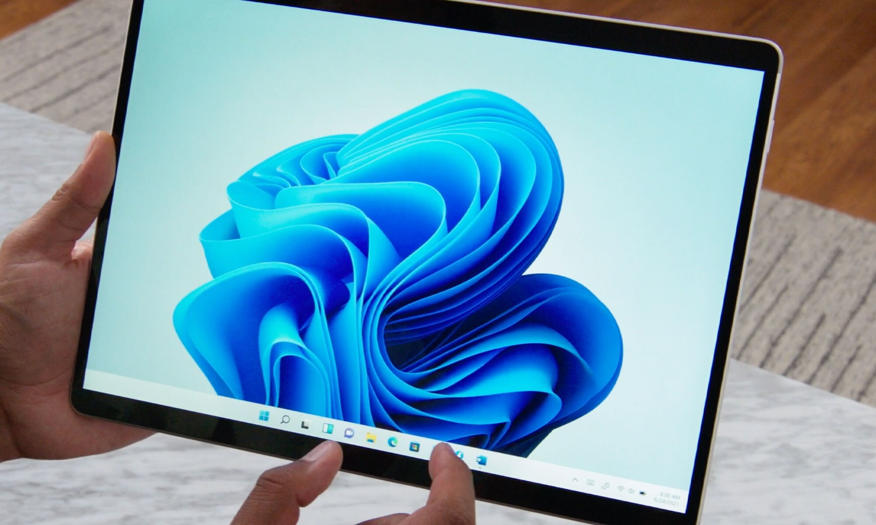

**Windows 10:**

**Familiar UI:** Easy for long-time users.

**High Compatibility:** Works with many old apps and hardware.

**Stable:** Known for reliability.

**Cost**-**Effective:** May be cheaper for some upgrades.

**App Pack Tips:**

Most apps work on both Windows 10 & 11.

Windows 11 runs faster but older apps might run slower.

Windows 11 is more secure.

New features in 11 help with multitasking and productivity.

**Conclusion: Windows 11 is more modern, secure, and feature-rich. But choose based on your needs and what works best for your apps.**

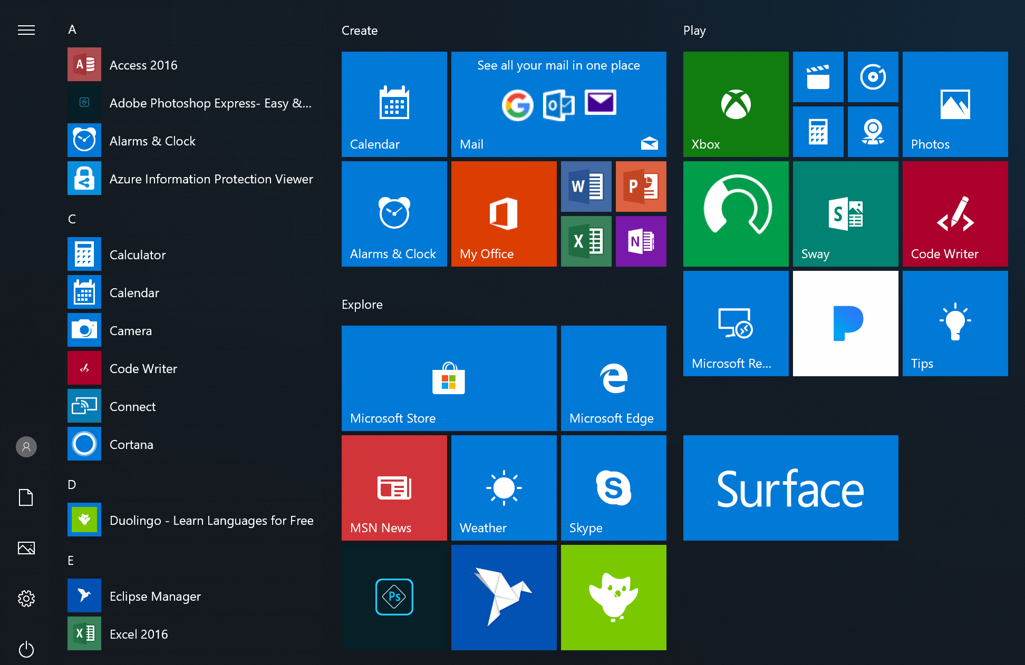

**Sysinternals**

1. **Autologon**

**→ Auto login setup for Windows.  
→ Great for test systems.**

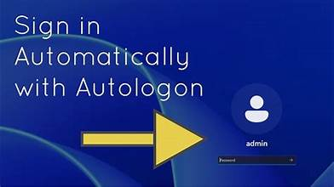

1. **Process Explorer**

**→ Shows detailed process info.  
→ Helps find issues or malware.**

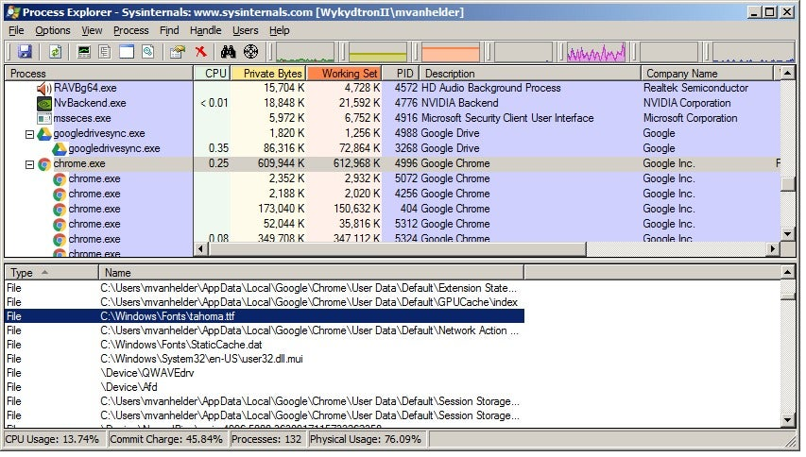

1. **PsExec**

**→ Run commands on remote PCs.  
→ Useful for remote admin tasks.**

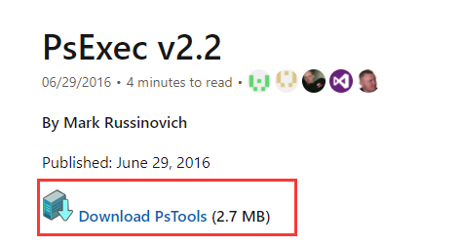

1. **PSTools**

**→ Toolkit for admin tasks.  
→ Includes PsList, PsFile, etc.**

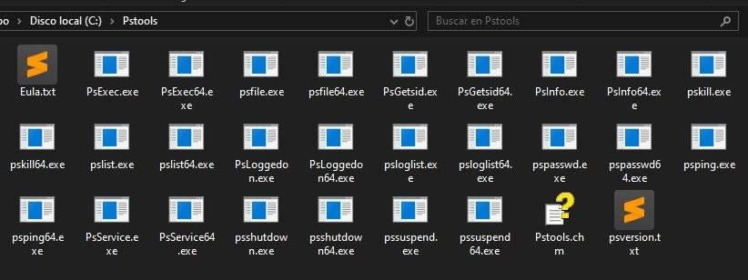

1. **RegMon**

**→ Tracks registry changes live.  
→ Good for registry debugging.**

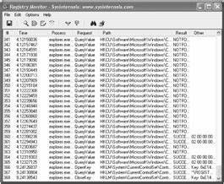

**Active Setup**

* **Purpose:** Runs user-specific setup during login.
* **How it works:** Compares **HKLM Version** vs **HKCU Version**.
* If **HKLM > HKCU**, it runs the command in **StubPath**.

**Points:**

**HKLM** = Global settings (Version, StubPath).

**HKCU = User-specific setup record.**

Version bump in HKLM = Forces Active Setup to run again.

